Lesson Plan

Handshake Programmer

Activity Overview
Students discover the importance of precise instructions through an iterative handshake programming activity.
Learning Objective  Students will understand the importance of precise instructions in AI training through an iterative programming simulation. | Standards & Competencies  - 1b (Understand Mechanics)  - 3a (Be innovative/persistent)  - CCSS.ELA.SL.4.1: Engage effectively in collaborative discussions with diverse partners, building on others' ideas and expressing their own clearly.
Materials  - Activity cards  - Recording sheets | Preparation  - Prepare command cards, hand cards, and recording sheets

Launch (3-5 minutes)
Slide | Exploration Guide
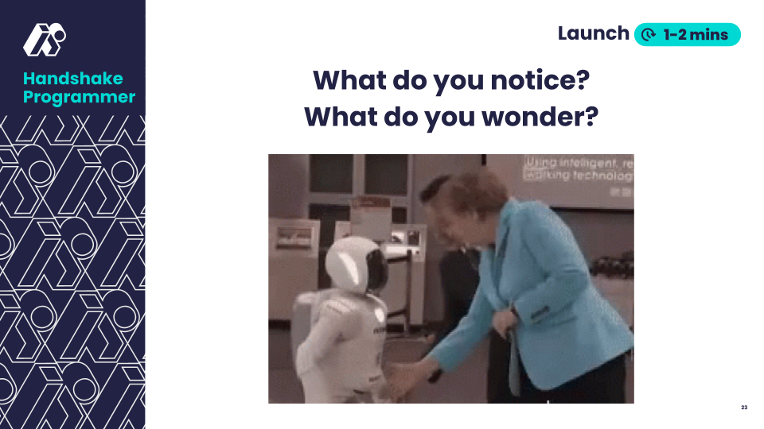 | Say: “What do you notice? What do you wonder?”  Students think independently for 30 seconds before sharing ideas.  Look For:  - The robot doesn’t do the handshake because it wasn’t programmed, or taught, how to do one.
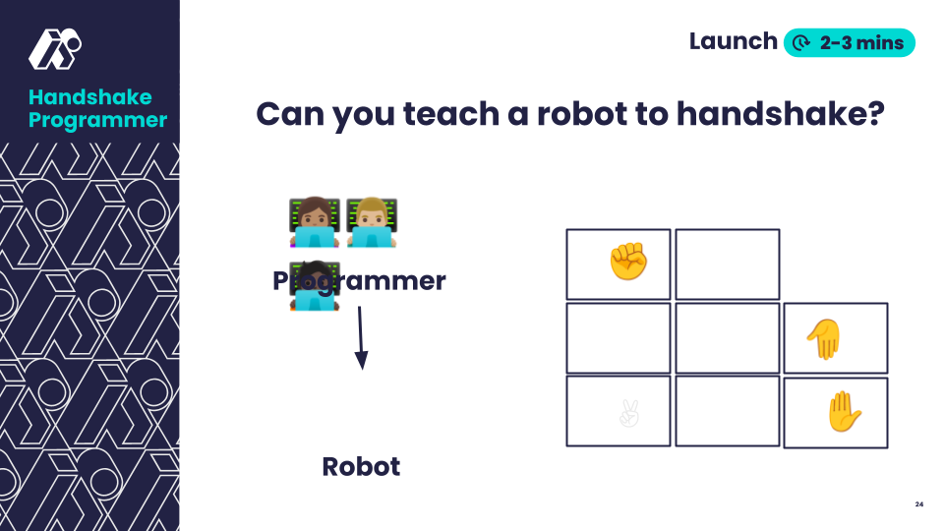 | Organize students into pairs and assign initial roles.  Say: “You're about to become AI programmers and robots. Your mission is to create handshake instructions that are so clear, any robot could follow them exactly. Programmers, you'll use the action cards and recording sheets to write your instructions. Bots, practice each action while programmers work. And remember, robots, act like you’ve never done a handshake before."  Demonstrate each action and give students time to practice.  Look For:  - Students following sequence exactly  - Notice and call out common variations in movements
💡Teaching Tip: Break down the sequence visually with: 1) Move name 2) Action Card 3) Physical demonstration

Play (10-12 minutes)
Slide | Exploration Guide
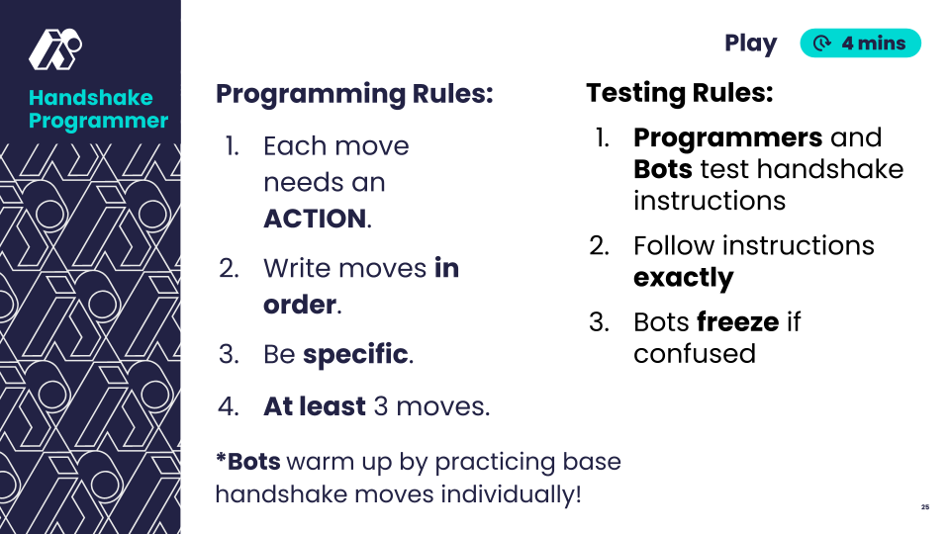 | Say: "Programmers, write your sequence using action cards. Bots, practice the moves you see on the cards."  Look for:  - Note any assumptions or missing details in programming instructions  Say: "Bots, your job is to follow instructions exactly. Try to act like you’ve never done a handshake before. If something isn't clear, freeze! Programmers, watch carefully."  Observe pairs and note common issues.  Look for:  - Student confusion about unclear sequences, especially which hand to use.
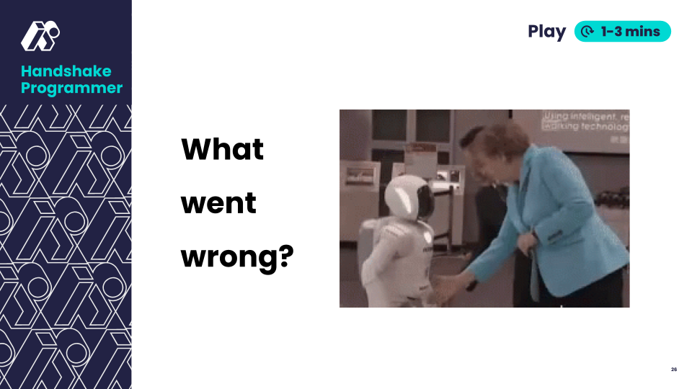 | Say: "What was unclear? What information was missing? Why did Bots interpret things differently?"  If necessary: stage demonstration to show a confused pair using right + left hand.  Look For:  - Students noticing the need to specify which hand to use.
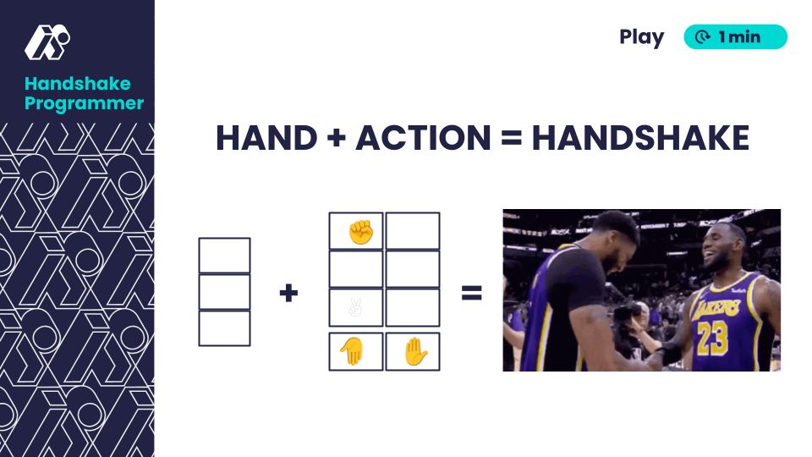 | Reveal and distribute hand cards to student groups.  Say: "Now we have a new tool - hand cards! How might these help make our instructions clearer?"
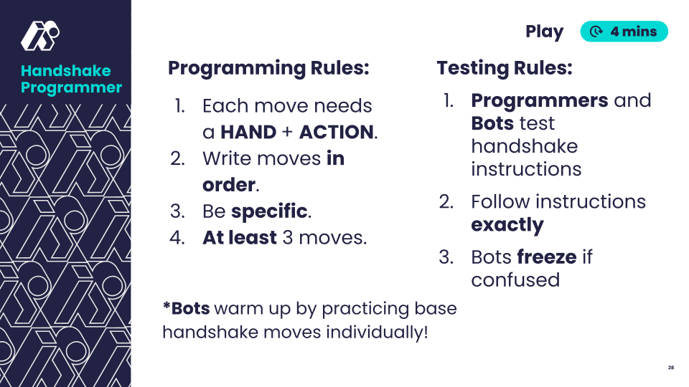 | Say: "Now each move needs both a HAND and an ACTION. Let's see if this makes our instructions clearer!"  Say: "Let's test our improved instructions. Bots, remember to freeze if anything is unclear."  Pairs test out their revised handshake sequences.  Look For:  - Smoother execution due to more detailed instructions
💡Teaching Tip: Provide visual formula: HAND + ACTION = Complete Instruction

Land (2-4 minutes)
Slide | Exploration Guide
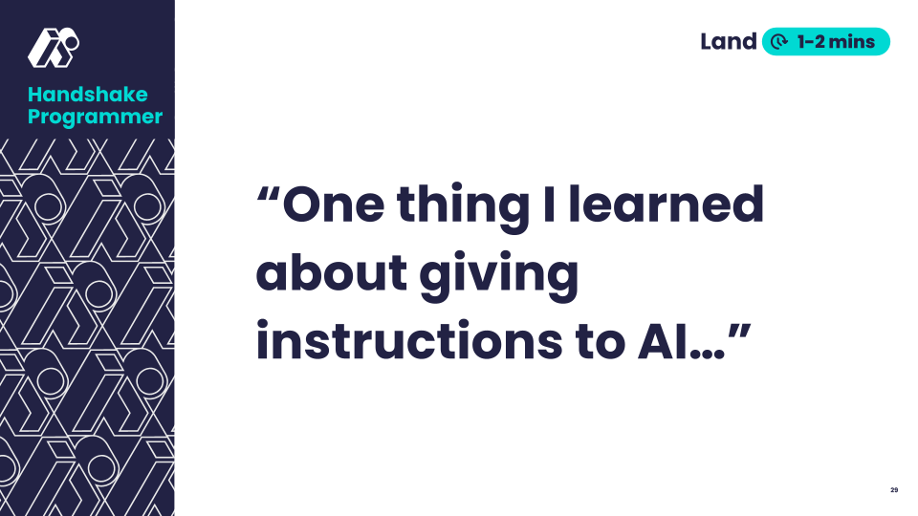 | Say: “Complete the sentence: ‘One thing I learners about giving instructions to AI…’”  Look For:  - Detailed instructions lead to better results  - Testing reveals missing information in instructions
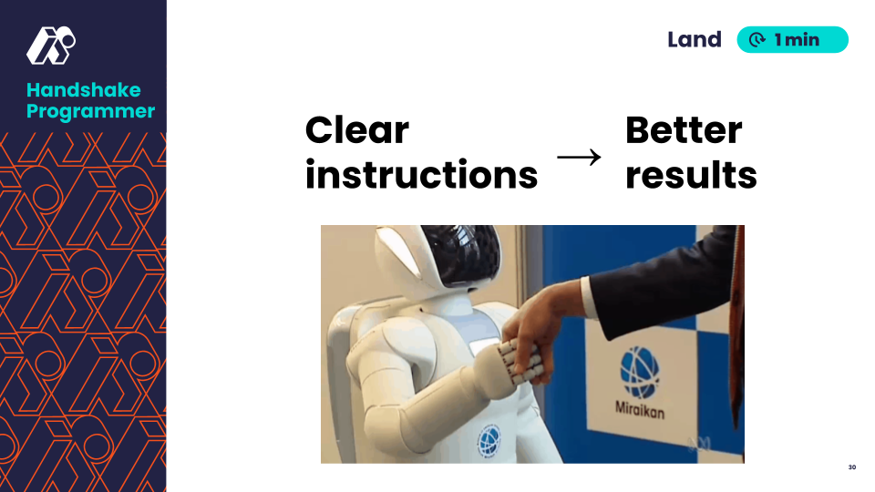 | Say: “Clearer, more detailed instructions lead to better results!’”
💡Teaching Tip: Provide students options to demonstrate understanding by writing, drawing, or speaking.

